Assignment 1

Olympic Climber Tracker Application

COS30017

DAC TUNG DUONG NGUYEN 104357292



Table of Contents

I. Acknowledgement 3

II. Introduction 3

III. Development Plan and Time Logs 3

1. Development PLan 3

2. Time Logs 3

IV. Key Design Decisions 3

1. UI/UX Design 3

Example result on Pixel 8 Pro API 35 3

Example result on Pixel Tablet 5

1. Functionality 6

2. Localization 6

3. Sound Effects and Animations 6

V. Issues Encountered and Solutions 6

Issue 1: Stable Data Across Orientation Changes 6

Problem 6

Solution 6

Issue 2: Localization/ Language Challenges 6

Problem 6

Solution 6

Issue 3: Sound Effects Clashing with Background Music 7

Problem: 7

Solution 7

Issue 4: Layout Issues on Tablet and Different Devices 7

Problem 7

Solution 7

VI. Reflection 7

1. What work well 7

2. What Could Be Improved 8

VII. Rubric Alignment 8

Github classroom link:

<https://github.com/SoftDevMobDev-2024-Classrooms/assignment01-Dan9704>

# Acknowledgement

No Generative AI tools were used for this task.

# Introduction

The Olympic Climber Tracker Application is a mobile application which is designed to track the progress of a climber on a modified climbing wall. The app allows users to record scores as climbers reach different holds on the wall. The application is designed with simplicity and usability in mind, featuring a clean interface that adapts to different screen orientations and supports localization in two languages (English and VietNamese).

# Development Plan and Time Logs

## Development PLan

The development of this application was completed over two weeks in order to meet the deadline, focusing on critical features and thorough testing to ensure high quality, plus point.

Week 3: Fundamental Features and UI/UX Design Important features including timers, reset buttons, and score monitoring were developed. The user interface was also created with both portrait and landscape orientations in mind.

Week 4: Testing, Debugging, and Enhancements carried out extensive testing on a variety of devices, fixed any problems, and added improvements including sound effects, animations, and localization.

## Time Logs

Week 3: 20 hours - Core functionality development and UI/UX design.

Week 4: 30 hours - Testing, debugging, localization, and feature enhancements.

# Key Design Decisions

## UI/UX Design

The development of a user-friendly interface that functions well in both portrait and landscape modes was given top priority. The structure of the app adapts to various screen sizes with ease, guaranteeing a consistent user experience across tablets and phones.

### Example result on Pixel 8 Pro API 35

Portrait

English Version

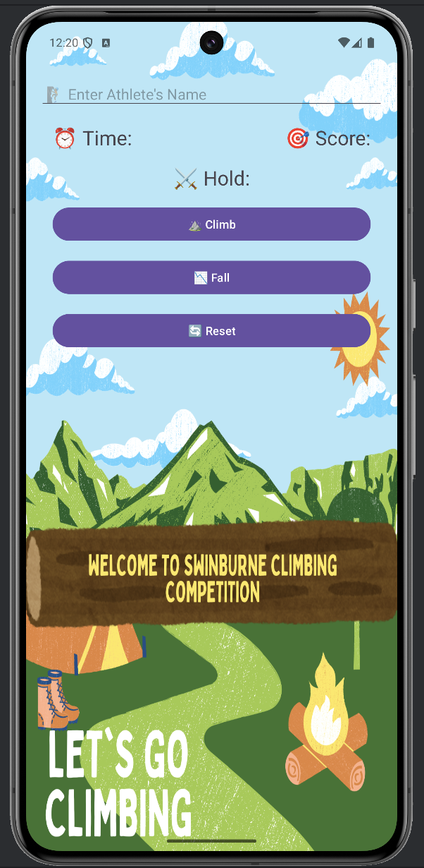 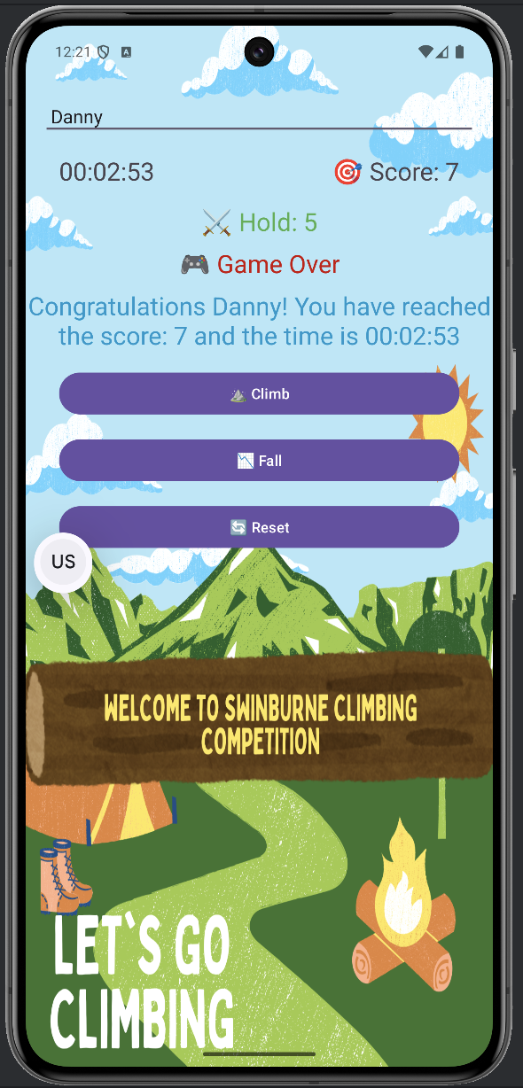 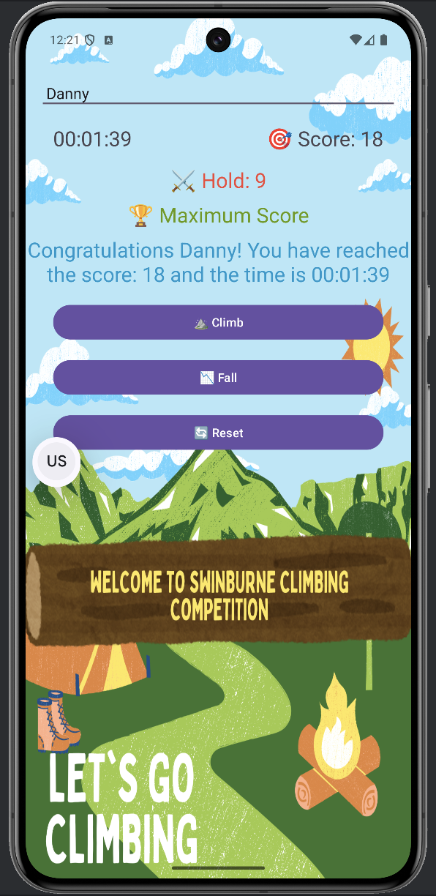

VietNamese Version

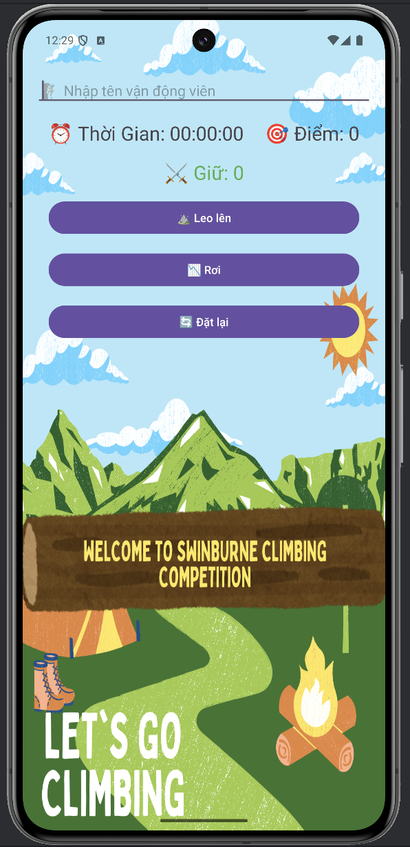 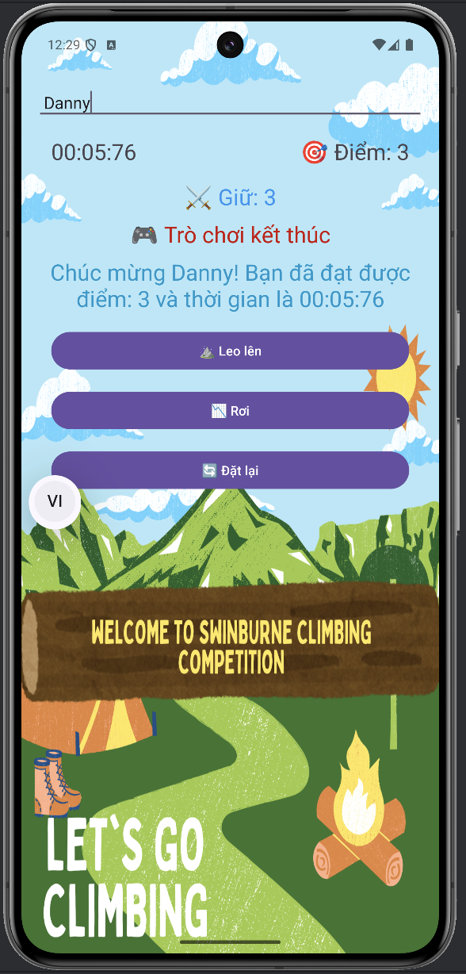 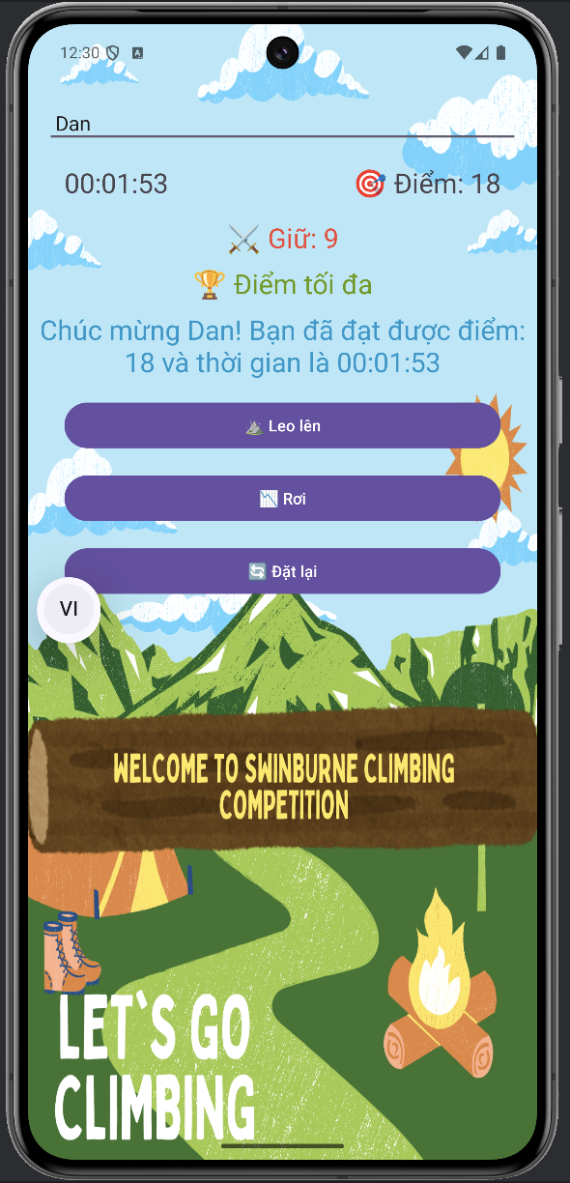

Landscape

English Version

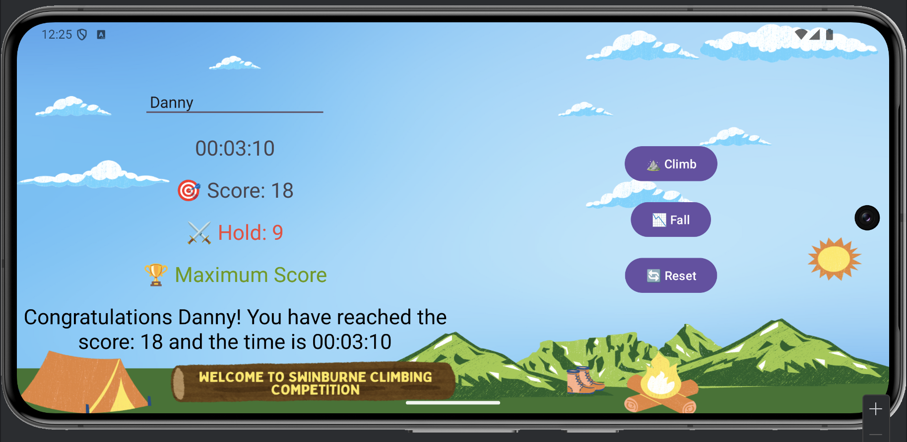

Vietnamese Version

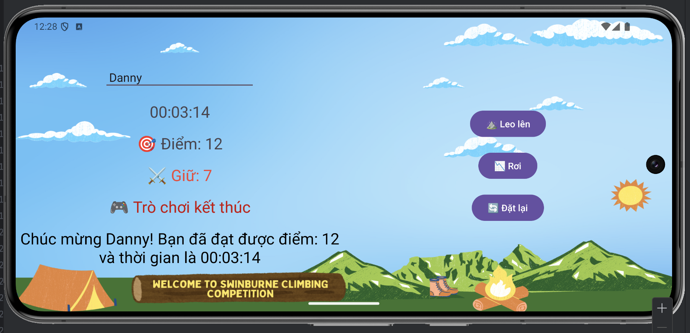

### Example result on Pixel Tablet

English Version

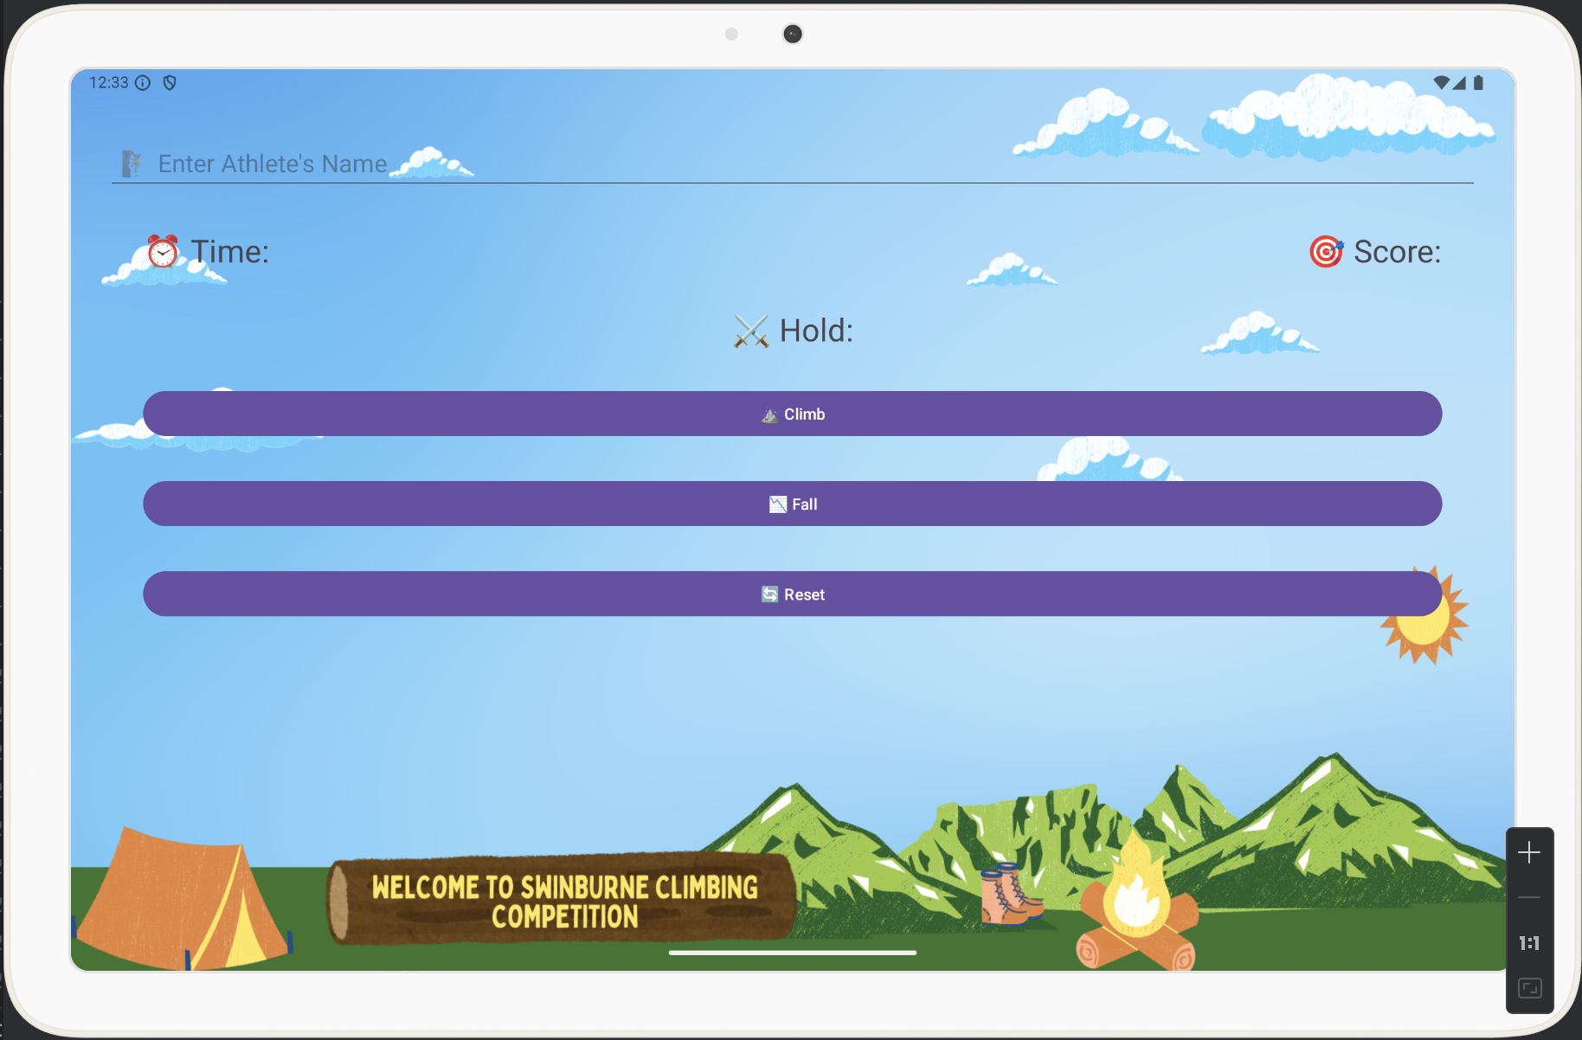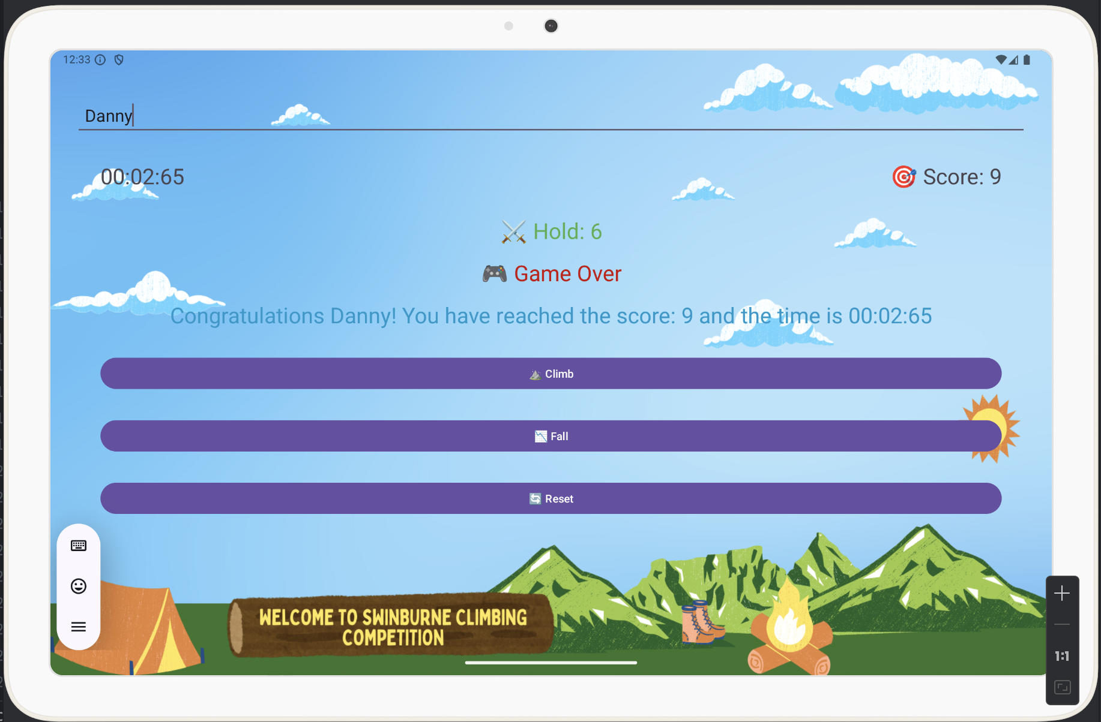

Vietnamese Version

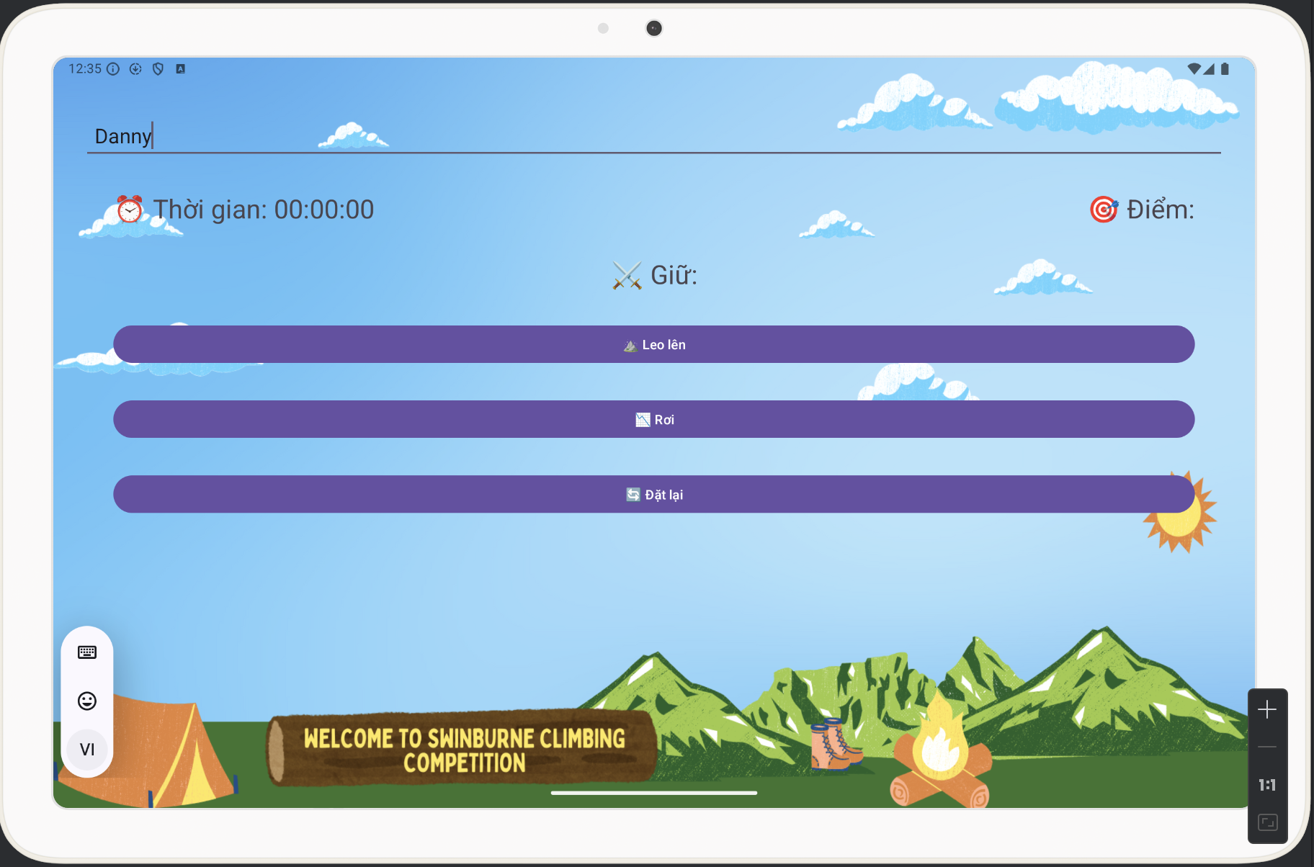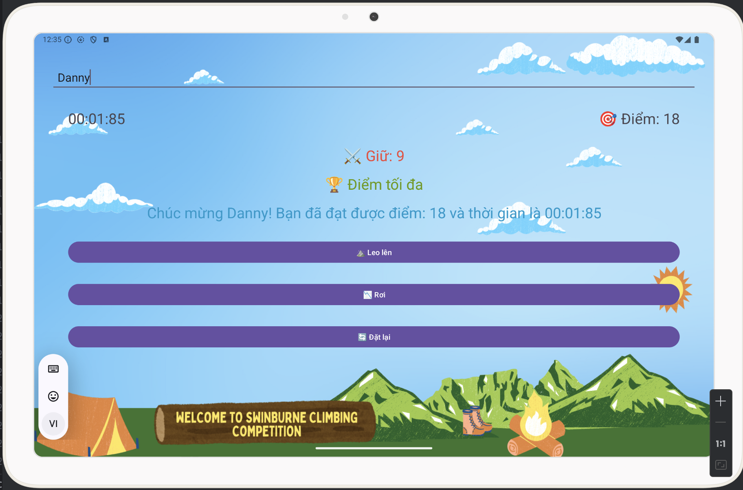

1. Functionality

The app has all the necessary features, like a countdown timer, a reset function, a bar where we can enter player’s name, and score monitoring. To increase user engagement, more features were included, such as animations for when a climber achieves the highest score and sound effects for various actions.

## Localization

The implementation of localization enabled users to transition between English and Vietnamese. In order to guarantee that the user interface text adapts dynamically according to the language selected, string resources had to be managed carefully.

## Sound Effects and Animations

Because the background is too noisy, sound effects were added for the climb and fall actions, and background music was played continually at 70% volume. The program becomes more interactive and interesting when the climber achieves the maximum score since a unique animation is played to showcase their accomplishment.

# Issues Encountered and Solutions

Detail the issues encountered during development and how they were addressed.

Issues Encountered and Solutions:

## Issue 1: Stable Data Across Orientation Changes

Problem: Scores and timer values were resetting when the device orientation is switched between Portrait and Landscape.

Solution: This issue was resolved by saving the current state using `onSaveInstanceState`.

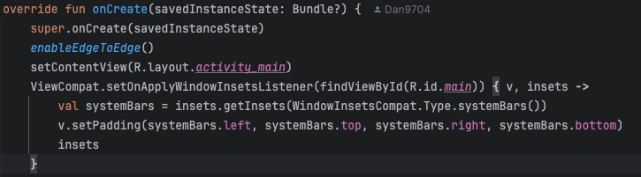

## Issue 2: Localization/ Language Challenges

Problem: Some strings were not correctly translated, and UI elements were not updating when the language was switched from English to Viet.

Solution: The issue was fixed by managing string resources where 2 file must be matching and ensuring that all UI elements dynamically update based on the selected language.

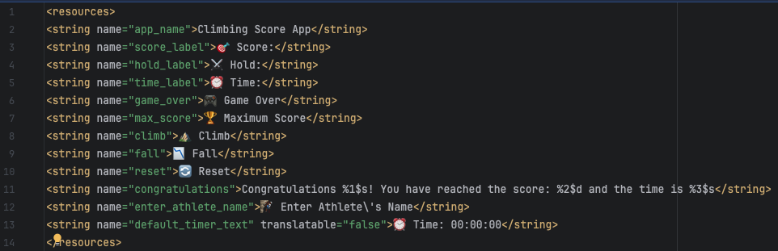

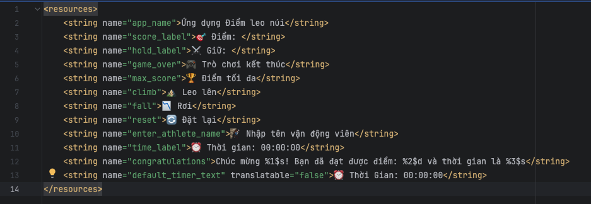

## Issue 3: Sound Effects Clashing with Background Music

Problem: The sound effects were clashing each other with the background music, making it difficult for users to hear the effects clearly and somehow too annoying.

Solution: Adjusted the volume of the background music to 70% by using online tool and ensured sound effects were distinct and clear, enhancing the user experience.

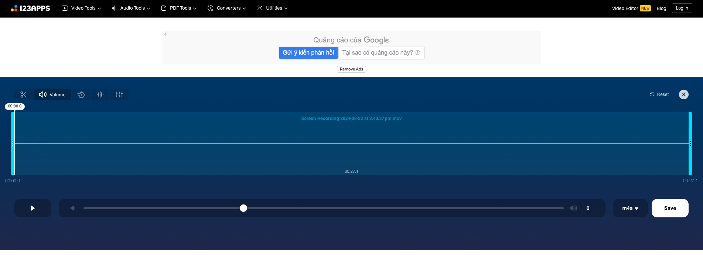

## Issue 4: Layout Issues on Tablet and Different Devices

Problem: The app layout appeared differently on tablets compared to phones making the background photo look awful.

Solution: Separate layout files were created for different screen sizes, design different background pictures which match different sizes ensuring a consistent look and feel across all devices.

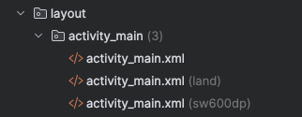

# Reflection

## What work well

* UI/UX: The design that I made is well structured and especially suit for various devices with different screen sizes. The feedback from my friend (who I ask him to try out my 1st app I made) was positive and he finds that the interface is very visually appealing.
* Function: Core functionalities like tracking, timer, reset were correctly implemented. Moreover I also add the function that user can enter athlete’s name which made my app easier for user keep track of score, stay away from mistakes. Sound effect and animations enhanced the user experience.
* Testing and Debugging. By checking the testing process thorough by different sizes different languages and devices, make sure that the app performed at its best. This step help me out identify and fix the issues before the submission.

## What Could Be Improved

* Device Compatibility: Although this app was tested on a specific set of devices, there are many more UI which need to be went through. With additional time spent on other larger, smaller devices would improve the app’s adaptability.
* Player Management: While the app had the player’name part, A function that help the app to store the record of player: date, time, and rank would make it perfectly.

# Rubric Alignment

1. UI/UX: The design was informed by some users, leading to a final application that provided excellent user experience.
2. Functionality: All required functionalities were met with extra features added for more wonderful experience.
3. Code quality: Attention to code style and documentation was maintained. Every single comments were added for understandings and improvement in the future.